1. **Define Dbms?**

* A database management system(Dbms) is a collection of program that enables users to create and maintain a database.
* The Dbms is general-purpose software system that facilities the process of defining, constructing, manipulating and sharing database among various users and application.

1. **Advantages of using Dbms approach**?

* **Control database redundancy :**

It can Control data redundancy because it stores all the data in one single database file and the recorded data is placed in the database.

* **Data sharing :**

In Dbms the authorized users of an organization can share the data among multiple users.

* **Easily maintenance :**

It can be due to the centralized nature of the database system

* **Reduce time** :

It reduce development time and maintainence need.

* **Backup:**

It provides backup and recovery subsystems which create automatic backup of data from hardware and software failure and restores the data if required

* **Multiple user interface:**

It provides different types of user interface like graphical user interfaces,application program interfaces

1. ?

* **Data Independence:**

One of the most important characteristics of the database approach is data independence. This refers to the ability to change the structure of the database without affecting the programs that access the data.

* **Data integrity :**

This refers to the accuracy and consistency of the data in the database. The database approach uses a variety of techniques to ensure data integrity, such as data validation, data constraints, and data normalization.

* **Data Sharing:**

his refers to the ability of multiple users to access and update the data in the database at the same time. The database approach uses a variety of techniques to ensure data sharing, such as locking and concurrency control.

* **Backup and Recovery :**

his is important in case of system failures or other unexpected events that may cause data loss. The database approach uses a variety of techniques to ensure that data can be backed up and recovered, such as database backups, transaction logs, and replication.

* **Scalability:**

This refers to the ability of the database to handle a large amount of data and a large number of users without performance degradation.

The database approach uses a variety of techniques to ensure scalability, such as horizontal scaling and vertical scaling.

* **Security:**

it ensures that the data is protected from unauthorized access, modification, or deletion.

The database approach uses a variety of techniques to ensure security, such as authentication, authorization, and encryption.

1. **What is database schema?**

* A database schema is a logical representation of data that shows how the data in a database should be stored logically.

It shows how the data is organized and the relationship between the tables.

* schema contains table, field, views and relation between different keys like primary key, foreign key.
* Data are stored in the form of files which is unstructured in nature which makes accessing the data difficult. Thus to resolve the issue the data are organized in structured way with the help of database schema.
* Database schema provides the organization of data and the relationship between the stored data.

1. **What is data models?**

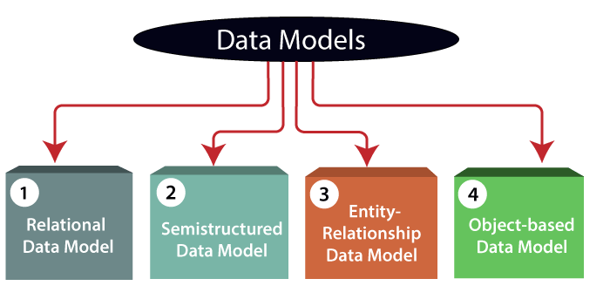

**A data model can be defined as an integrated collection of concepts describing and manipulating data, as well as constraints on the data within an organization.** A data model is not just a set of tables; it is a conceptual representation of physical data stored in the database.

* **Relational Data Model :** This type of model designs the data in the form of rows and columns within a table. Thus, a relational model uses tables for representing data and in-between relationships. Tables are also called relations. The relational data model is the widely used model which is primarily used by commercial data processing applications.
* **Entity-Relationship Data Model:** An ER model is the logical representation of data as objects and relationships among them. These objects are known as entities, and relationship is an association among these entities. It was widely used in database designing.
* **Object-based Data Model:** An extension of the ER model with notions of functions, encapsulation, and object identity, as well. This model supports a rich type system that includes structured and collection types.
* **Semistructured Data Model :** The semistructured data model allows the data specifications at places where the individual data items of the same type may have different attributes sets. The Extensible Markup Language, also known as XML, is widely used for representing the semistructured data.

1. **define data independence, physical and logical data independence**

**Data Independence :**

Data independence refers characteristic of being able to modify the schema at one level of the database system without altering the schema at the next higher level.

There are two types of data independence:

* Logical Data Independence
* Logical data independence refers characteristic of being able to change the conceptual schema without having to change the external schema.
* Logical data independence is used to separate the external level from the conceptual view.
* If we do any changes in the conceptual view of the data, then the user view of the data would not be affected.
* Logical data independence occurs at the user interface level.
* Physical Data Independence
* Physical data independence can be defined as the capacity to change the internal schema without having to change the conceptual schema.
* If we do any changes in the storage size of the database system server, then the Conceptual structure of the database will not be affected.
* Physical data independence is used to separate conceptual levels from the internal levels.
* Physical data independence occurs at the logical interface level.

1. **What is client server architecture in DBMS ?**

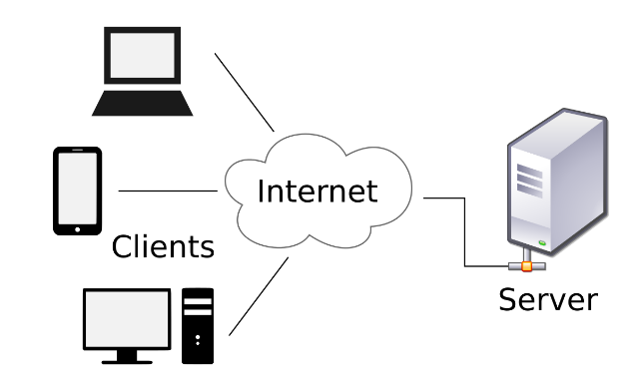Client server architecture is a computing model in which the server hosts. Delivers and manages most of the resources and services to be consumed by the client . This type of architecture has one or more client computers connected to a central sever over a network or internet connection